**DID YOU KNOW?**

Title insurance only insures to the property line?

Title insurance excludes coverage for listed exceptions?

Title insurance policies exclude coverage for zoning, encroachments, and other matters that could be a real problem for a buyer?

Only an attorney can advise on title matters?

We know and now you do too.

**Let us help you avoid problems with your customers and closings!**

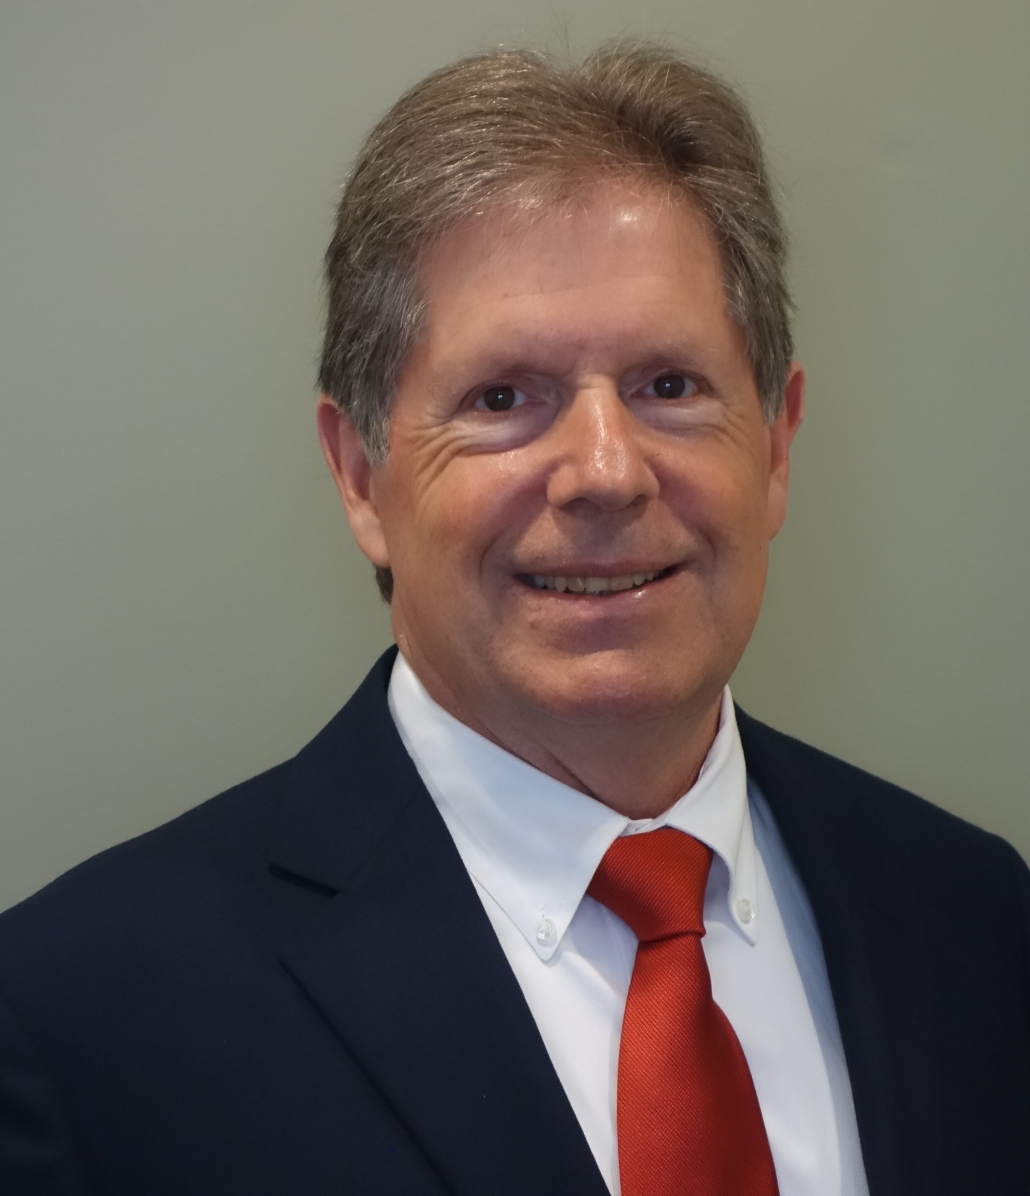

**Law Offices of William G. Morris, P.A.**

247 North Collier Boulevard, Suite 202

Marco Island, Florida 34145

Telephone (239) 642-6020

[wgm@wgmorrislaw.com](mailto:wgm@wgmorrislaw.com)