**DID YOU KNOW?**

Turn key or fully furnished are not legally defined terms?

That those terms can lead to a lawsuit over what is to be included in a sale?

We know the problems caused by bad terms. Let us help you avoid problems.

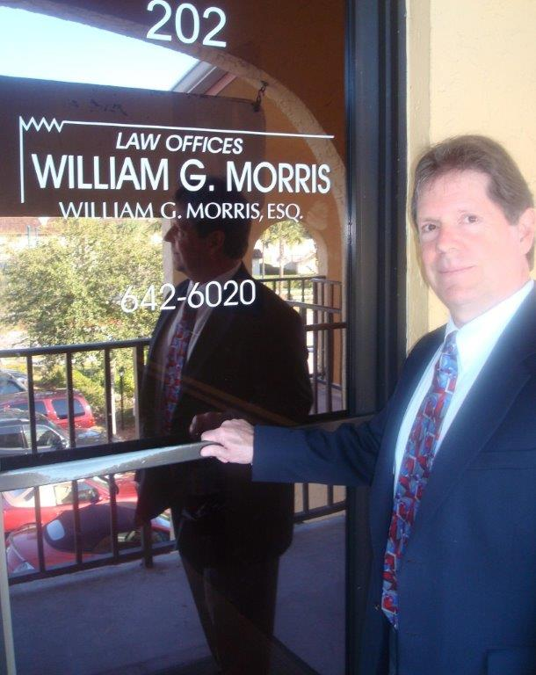

**Law Offices of William G. Morris, P.A.**

247 North Collier Boulevard, Suite 202

Marco Island, Florida 34145

Telephone (239) 642-6020

[wgm@wgmorrislaw.com](mailto:wgm@wgmorrislaw.com)