**DID YOU KNOW?**

Our firm has been committed to helping Realtors since 1983.

We have continued that commitment by not refusing to assist with new contracts because we are busy.

We are available 7 days a week.

We are here for you and your customers.

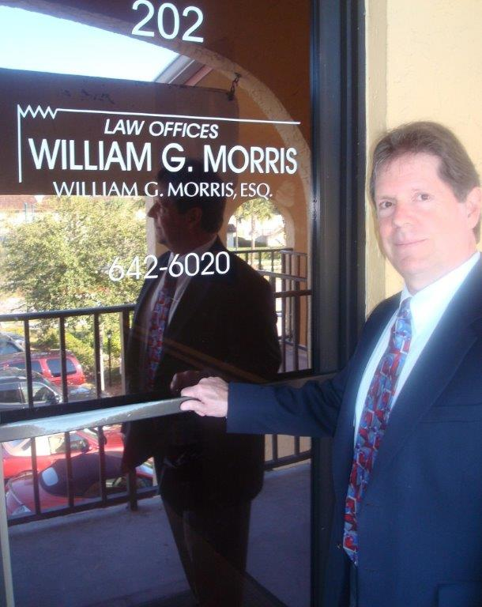

**Law Offices of William G. Morris, P.A.**

247 North Collier Boulevard, Suite 202

Marco Island, Florida 34145

Telephone (239) 642-6020

[wgm@wgmorrislaw.com](mailto:wgm@wgmorrislaw.com)