**DID YOU KNOW?**

Both NABOR and FR/BAR “As Is” contracts allow the Buyer to cancel for no reason?

That FR/BAR has no real “as is” contract but NABOR’s Residential Improved contract can be “as is” by checking “WAIVER” under Section 8 for inspections?

We know …. Bill Morris helped draft the NABOR forms.

Let us help you avoid or solve problems with your next transaction.

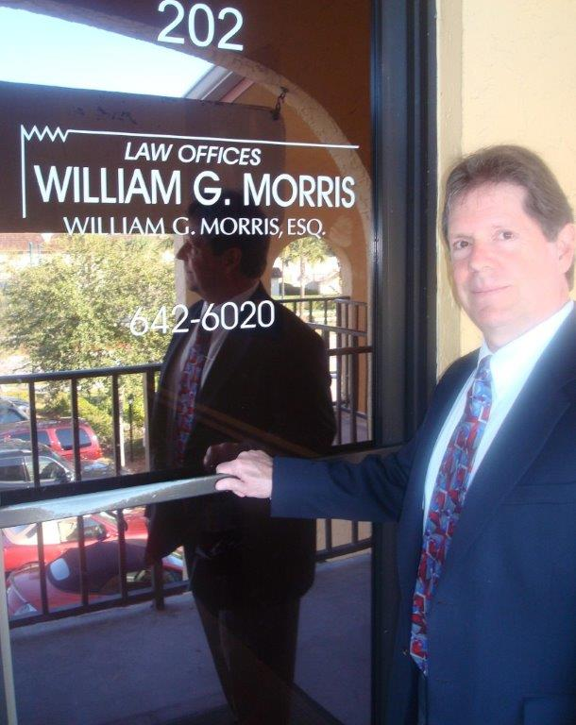

**Law Offices of William G. Morris, P.A.**

247 North Collier Boulevard, Suite 202

Marco Island, Florida 34145

Telephone (239) 642-6020

[wgm@wgmorrislaw.com](mailto:wgm@wgmorrislaw.com)