DID YOU KNOW,

“Newly remodeled” can create liability?

Remodels almost always require permits. That makes permit searches critical, and if a Realtor does not help make sure that gets done, who do you think the buyer will blame?

Let us help!!

Law Offices of William G. Morris, P.A.
247 North Collier Boulevard Suite 202
Marco Island, Florida 34145
Telephone (239) 642-6020
Facsimile (239) 642-0722
wgm@wgmorrislaw.com

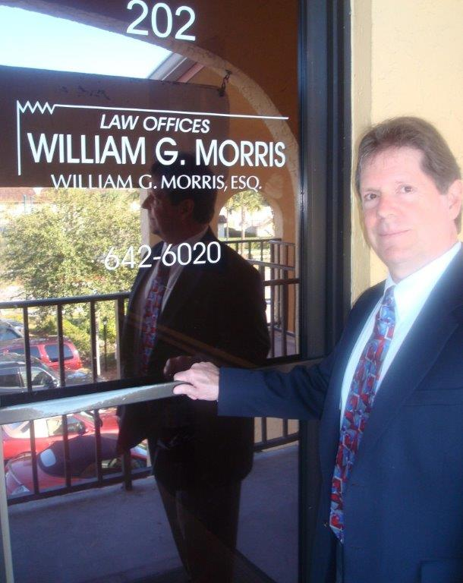

Our firm offers a broad spectrum of legal representation including, but not limited to:

Estate Planning & Probate | Condominium / HOA Law | Litigation & Appeals
Landlord / Tenant Disputes | Business Organization | Family Law
Business & Commercial Law | Personal Injury/ Plaintiff | Wills & Trusts

