**Are you making yourself a target for lawsuits?**

Realtors are vulnerable when it comes to being sued and reputation in a referral business such as real estate is extremely important.

Take proactive steps to protect your career, customers, and reputation!

We understand your customers want answers but **DO NOT GIVE LEGAL ADVICE!** The last thing you want is liability for practicing law without a license and a claim for giving bad advice.

We are a law firm and can provide legal advice and draft documents. Two things Realtors cannot do!

Cost of closing with our firm is often less than the closing cost with a title company! Let us provide the added benefit of protection only an attorney can provide.

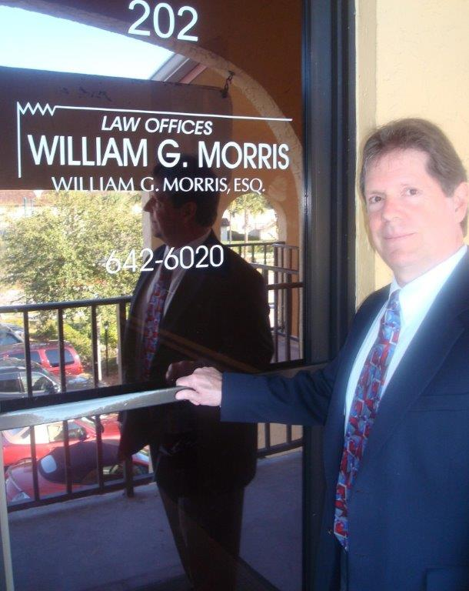

**Law Offices of William G. Morris, P.A.**

247 North Collier Boulevard, Suite 202

Marco Island, Florida 34145

Telephone (239) 642-6020

[wgm@wgmorrislaw.com](mailto:wgm@wgmorrislaw.com)