**DID YOU KNOW?**

Power of Attorney to sign a deed in Florida must have two signing witnesses and a notary acknowledgement. Be careful if using a Power of Attorney from another state.

**Power of Attorney Requirements:**

* POA should clearly identify the principle and agent being appointed
* Name of the principal should match the recorded deed
* POA needs specific powers (sell, convey, mortgage, encumber, lease, execute deeds, closing documents, etc.)
* POA needs to be properly notarized with seal affixed
* Original POA will be needed for recording

Let us help before you find out the POA is not valid before closing.

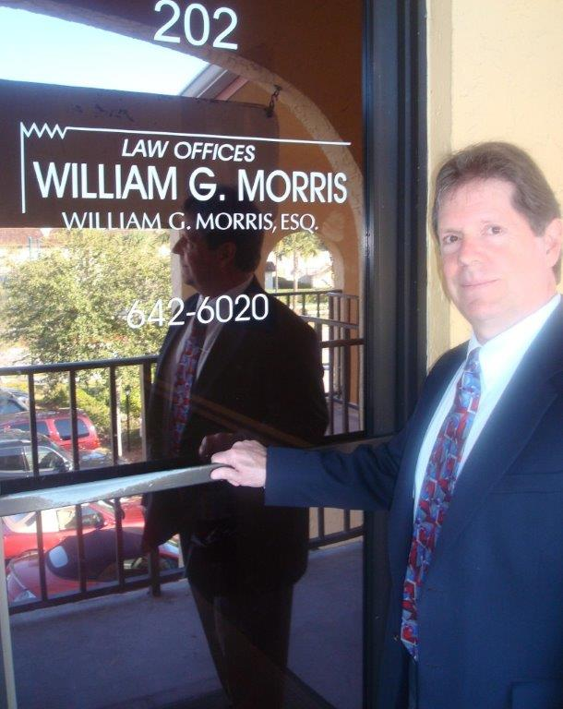

**Law Offices of William G. Morris, P.A.**

247 North Collier Boulevard, Suite 202

Marco Island, Florida 34145

Telephone (239) 642-6020

[wgm@wgmorrislaw.com](mailto:wgm@wgmorrislaw.com)