**Did you know?**

Do you have a dead owner?

If a Will does not include power to sell real estate, Florida court permission will be needed even if a Personal Representative has been appointed by a Florida court.

If you are listing property that is still in the name of a decedent, we can determine what’s needed to transfer title.

We are here to help! Let us help you write contracts and close sales to protect all parties involved in a real estate transaction.

We are just a phone call away!

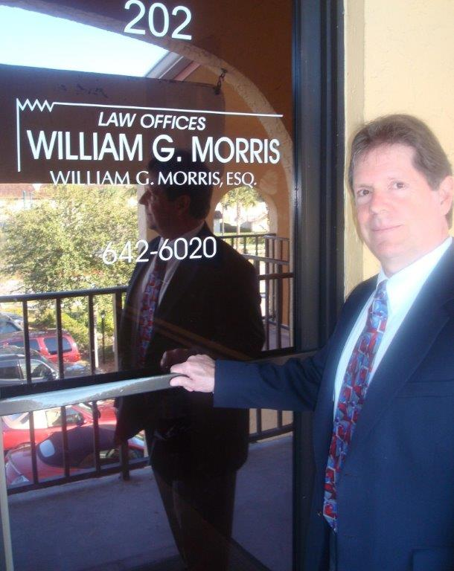

**Law Offices of William G. Morris, P.A.**

247 North Collier Boulevard, Suite 202

Marco Island, Florida 34145

Telephone (239) 642-6020

[wgm@wgmorrislaw.com](mailto:wgm@wgmorrislaw.com)