**Did you know?**

Title insurance includes protection against hidden defects that would not be obvious in a title search. These defects include forged deeds, impersonation of another by identity theft, married seller who represents himself or herself as single, mistakes in the Clerk’s office or in indexing documents in the Public Records and even mistakes in title search or review.

There is almost always a gap in time between the last title search and recordation of the deed from closing. That gap exposes the buyer to risk of claims being filed against the seller or the property between the latest title search and recording of the deed. By statute, Florida requires title insurance underwriters insure against the possible existence of adverse matters or defects in title between the effective date of any title commitment and the date of recording the deed, if an appropriate Gap Affidavit is obtained from the Seller.

Not all title defects render title uninsurable and solving these issues requires more than merely getting a title policy.

**Let us protect your customers and help them to a smooth closing!**

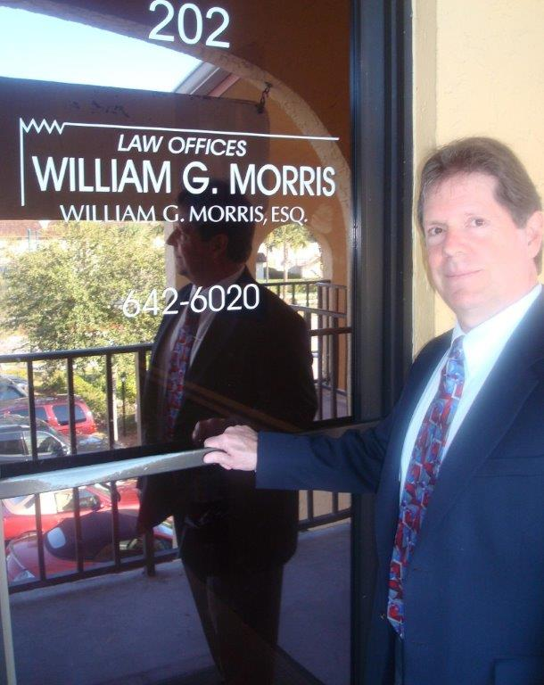

**Law Offices of William G. Morris, P.A.**

247 North Collier Boulevard, Suite 202

Marco Island, Florida 34145

Telephone (239) 642-6020

[wgm@wgmorrislaw.com](mailto:wgm@wgmorrislaw.com)