**Did you know?**

* Attorneys provide Realtors with an increased level of protection
* We have over 30 years of experience in real estate law and will provide counsel on legal issues that may arise.
* We work with Realtors as a team and will review and assist with writing sales contracts, addendums and specific contingency clauses to avoid problems and provide protection
* We provide advice on how to take title and other aspects of the transaction, leases, financing, homestead, zoning matters etc.
* We prepare deeds, leases, affidavits, mortgages, and other conveyance documents, and prepare and file FIRPTA applications

**Let us protect your clients and your sales!**

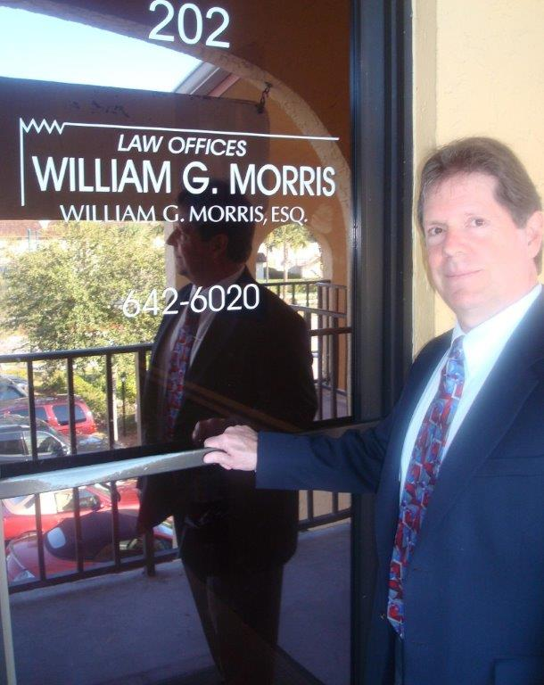

Law Offices of William G. Morris, P.A.

247 North Collier Boulevard, Suite 202

Marco Island, Florida 34145

Telephone (239) 642-6020

[wgm@wgmorrislaw.com](mailto:wgm@wgmorrislaw.com)