**What do you know about title insurance?**

Almost everyone knows title insurance protects the owner’s interest for the full value of the policy and insures that the title is marketable.

Many times we hear, “Why do I need title insurance? The buyer is a good friend, there are no liens, and you’re researching title.”

Title insurance includes protection against hidden defects that would not be obvious in a title search. These defects include forged deeds, impersonation of another by identity theft, married seller who represents himself or herself as single, mistakes in the Clerk’s office or in indexing documents in the Public Records and even mistakes in title search or review.

Title insurance starts with a professional title search as the basis for the policy – and that search also protects the buyer by uncovering the obvious problems. Not all title defects render title uninsurable and solving these issues requires more than merely getting a title policy.

**Let us protect your customers and help them to a smooth closing!**

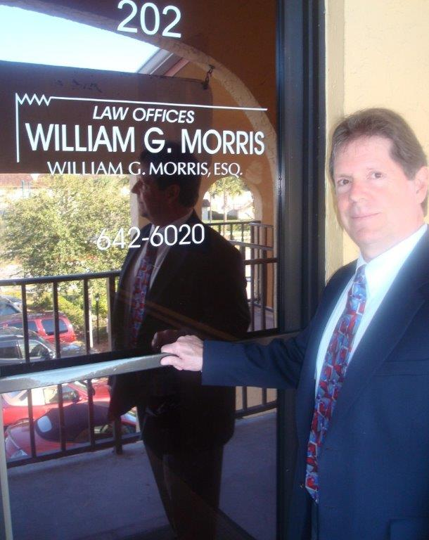

**Law Offices of William G. Morris, P.A.**

247 North Collier Boulevard, Suite 202

Marco Island, Florida 34145

Telephone (239) 642-6020

[wgm@wgmorrislaw.com](mailto:wgm@wgmorrislaw.com)