**Do you know why you should use an attorney to handle your real estate transaction instead of a title company?**

* Title companies cannot prepare a Bill of Sale or Personal Property Contracts
* Title companies cannot give legal advice. If your client does not know how to take title; or there is a title problem, the title company cannot help.
* We give advice on how to take title and other aspects of the transaction, including leases, wraparound / subject to financing, homestead, zoning matters, trust and entities
* We review and assist with writing contracts, addenduas, affidavits, mortgages, other conveyance documents, and clauses to avoid problems and provide protection
* The promulgated rate for the title insurance premium is the same everywhere in Florida.

**We specialize in real estate law advice and unquestioned loyalty to only you for the same or less cost than a title company.**

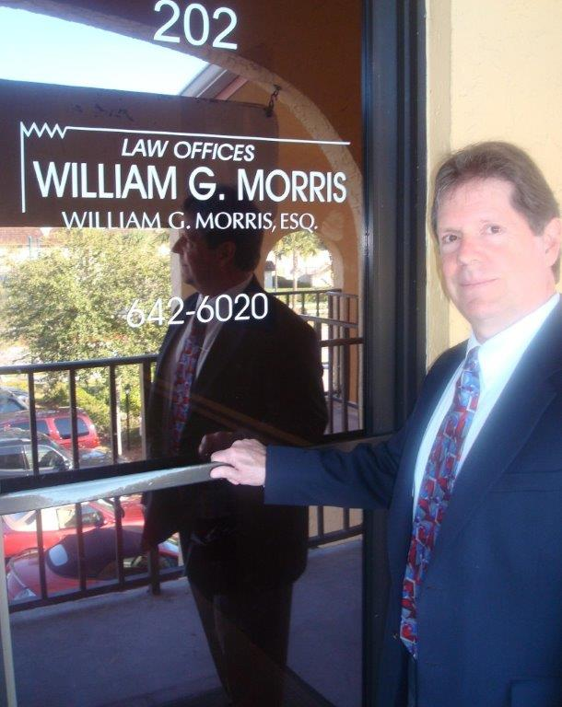

Law Offices of William G. Morris, P.A.

247 North Collier Boulevard, Suite 202

Marco Island, Florida 34145

Telephone (239) 642-6020

[wgm@wgmorrislaw.com](mailto:wgm@wgmorrislaw.com)