**Why use us as your attorney?**

* Will provide agents with an increased level of protection
* Experts in real estate law and will provide counsel on legal issues that may arise
* Can review and assist with writing sales contracts, addendums and specific contingency clauses in order to avoid problems and provide protection
* Give advice on how to take title and other aspects of the transaction, including leases, wraparound / subject to financing, homestead, zoning matters etc.
* Prepare deeds, leases, affidavits, mortgages, and other conveyance documents
* Prepare and file FIRPTA applications

**Let us protect your clients and your sales!**

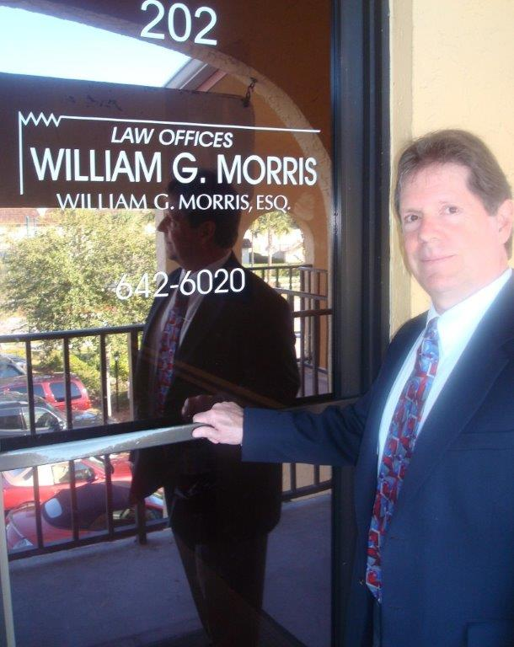

Law Offices of William G. Morris, P.A.

247 North Collier Boulevard, Suite 202

Marco Island, Florida 34145

Telephone (239) 642-6020

[wgm@wgmorrislaw.com](mailto:wgm@wgmorrislaw.com)