DID YOU KNOW?

Under the FARBAR contract, if the Buyer decides to cancel the contract for any reason not covered by a contingency, the Buyer forfeits any deposit made PLUS all deposits required but not yet made, under the contract.

Let us protect your clients and your sales.

Law Offices of William G. Morris, P.A.
247 North Collier Boulevard, Suite 202
Marco Island, Florida 34145
Telephone (239) 642-6020
wgm@wgmorrislaw.com

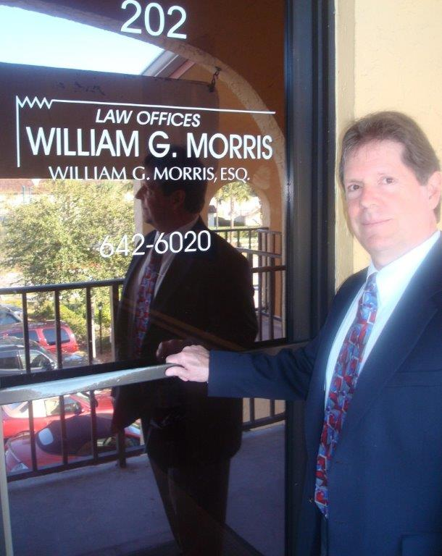

*The hiring of an attorney is an important decision and should not be based solely on advertisement.
Before you decide, ask our firm for additional information about our qualifications and experience.

