The Law Offices of William G. Morris, P.A.
Meeting Collier County’s legal needs for over 30 years
247 North Collier Boulevard, Suite 202
Marco Island, Florida 34145
Telephone (239) 642-6020
Facsimile (239) 642-0722
wgm@wgmorrislaw.com

William G. Morris, P.A., recently became certified in accordance with the American Land Title Association’s Best Practices.
National Certified Public Accounting and consulting firm Pershing, Yoakley & Associates (PYA) provided the assessment and certification of William G. Morris, P.A.
With this certification, the firm has established and is adhering to documents operational policies that reflect all of the best practices.

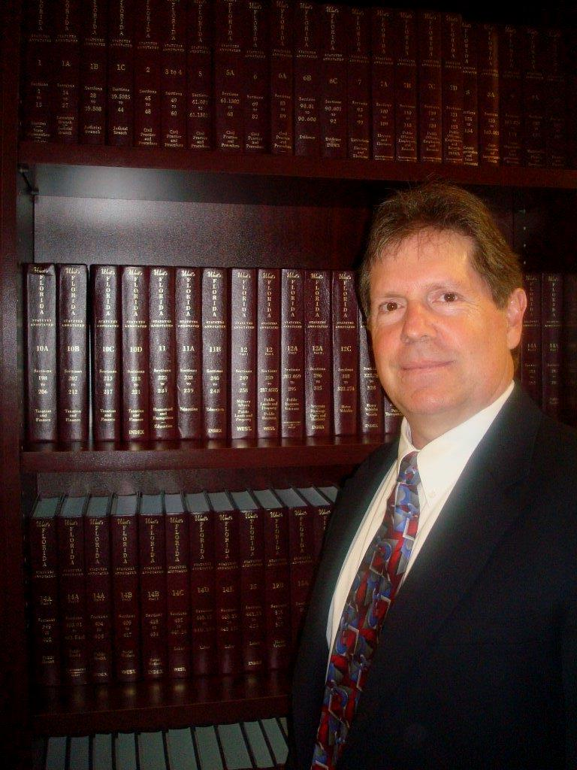
Our firm is proud to be at the forefront of best practices implantation and certification. This certification qualifies the firm to close real estate mortgages with those lenders requiring the highest level of security and qualification.
The hiring of an attorney is an important decision that should not be based solely on advertisement. Before you decide, ask us to send you free written information about our qualifications and experience.

